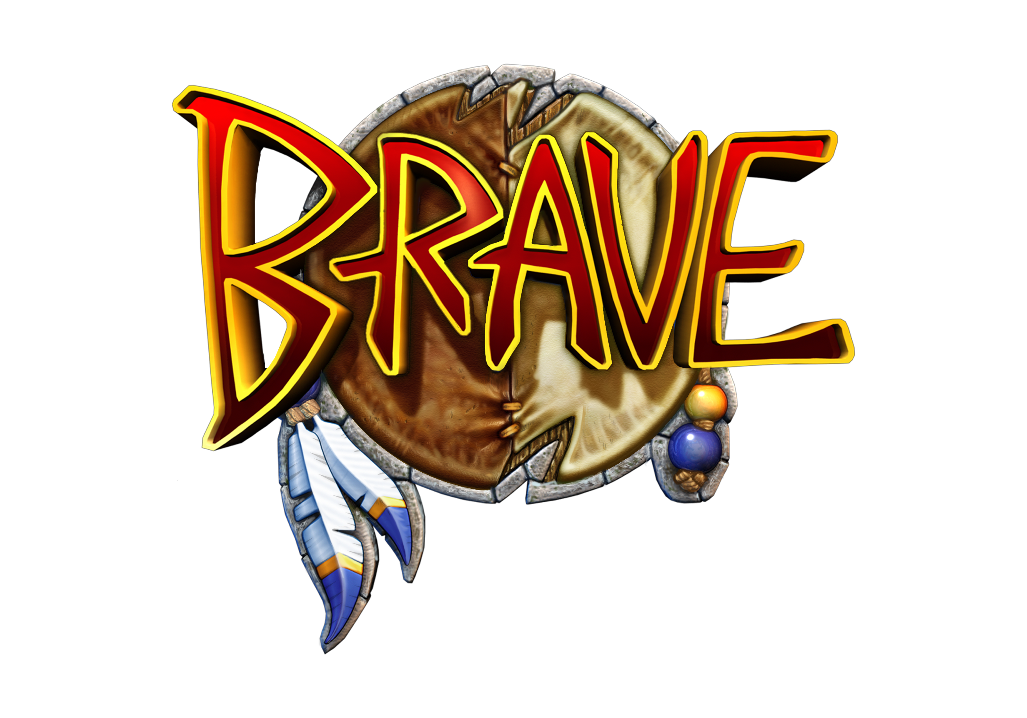

Brave: The Search for Spirit Dancer

1st Feb 2005 – Sony Computer Entertainment Europe are delighted to announce the June release of ‘Brave: The Search for Spirit Dancer’. Developed by Edinburgh-based VIS Entertainment ltd, ‘Brave: The Search for Spirit Dancer’ is an platform adventure game exclusive to the PlayStation®2.

Set in a fantastic world based upon the mythology of Native America, the game tells the coming of age story of ‘Brave’ a young Native American boy embarking on an epic journey to save his tribe. When his village is set upon by the evil Wendigo, and his friends are enslaved, Brave is sent to find the only one that can free them - Spirit Dancer, the greatest Shaman who ever lived.

Hunting snarling evil wolves in a huge forest of towering Redwood trees, canoeing down raging river rapids, tracking the legendary Sasquatch through a swirling blizzard and battling on the back of a buffalo in the middle of a stampede are just some of the breathtaking challenges Brave will face. His journey will take him across a beautifully rich and interactive world inhabited by remarkable characters, bizarre creatures, and terrifying evil spirits.

Learning the ways of his people, Brave must master not only combat with tomahawk and bow and arrow, but also the skills of a hunter: animal tracking, mimicry and survival. He will learn to swim and dive, to climb trees and leap across rock-faces and traverse perilous frozen waterfalls with two ice axes his only support. As he builds in power he will also be taught the ways of a Shaman - how to summon the Great Eagle Spirit and fly on its back and possess creatures from the smallest rabbit to a mighty Grizzly Bear Spirit.

His journey will not be easy, but it’s a journey he must take, a journey fraught with danger and revelation - The Search for Spirit Dancer.

-Ends-

Sony Computer Entertainment Europe Ltd.
Sony Computer Entertainment Europe, based in London, is responsible for the distribution, marketing and sales of PS one and PlayStation 2 software and hardware in 102 territories across Europe, the Middle East, Africa and Oceania. At the end of September 2004, over 39 million PlayStation units had been shipped across these PAL territories, over 100 million worldwide. Between its European debut on 24 November 2000 and the end of September 2004, over 25 million PlayStation 2 units have been shipped across the PAL territories, over 74 million world-wide, making it one of the most successful consumer electronic products in history.

PlayStation and the PlayStation logo are registered trademarks, PS one and PS2 are trademarks of Sony Computer Entertainment Inc. All other trademarks are property of their respective owners.

More information about PlayStation products can be found at http://www.scee.com and www.playstation.com.

VIS entertainment ltd.
VIS entertainment ltd is a leading Video Games Developer based in Scotland. Founded in 1996, VIS has developed games for all major console formats and had global success in 2002 with the worldwide No. 1 State of Emergency. VIS entertainment ltd consists of VIS Games and associated companies Axis Animation. The company has studios in Dundee and Edinburgh. Since 2004 the company has been a subsidiary of BAM! Entertainment inc. (BFUN) a US based games publisher.

